1. Setup

To setup the project, please open the solution file with visual studio and compile it. After it’s compiled, you can either run the web app via VS studio IIS express or set up local IIS server, the former is preferred as it’s automatically set up by VS studio

1. Using the Web App

When the app first started, you will land on directly to the SEO analyser page

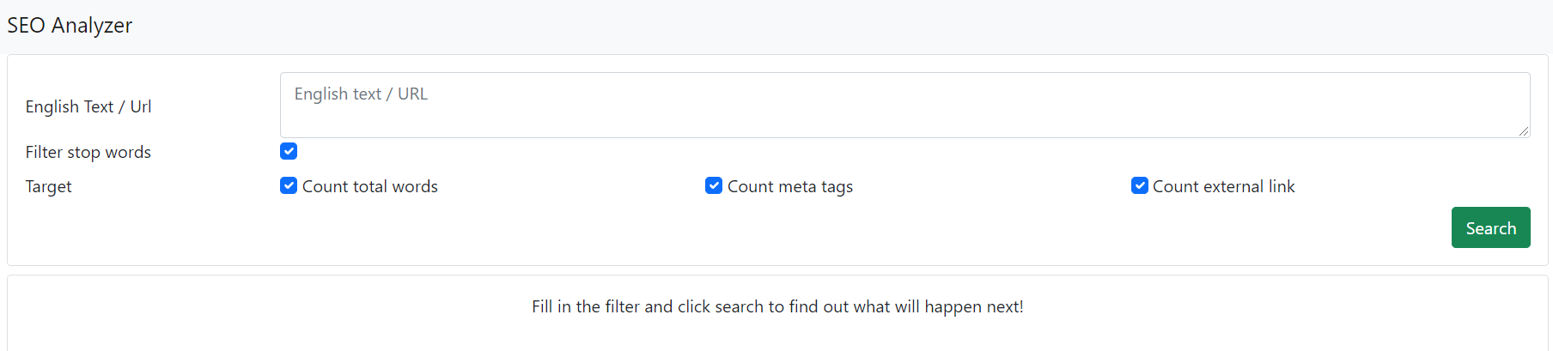

To start, you can fill in either English text or a URL.

1. English Text

If English texts are used for the search criteria, the app will split all of the sentences using common separator such as comma, spaces, and full stop. You will receive a grouped result with their repetition counts just below the filter section.

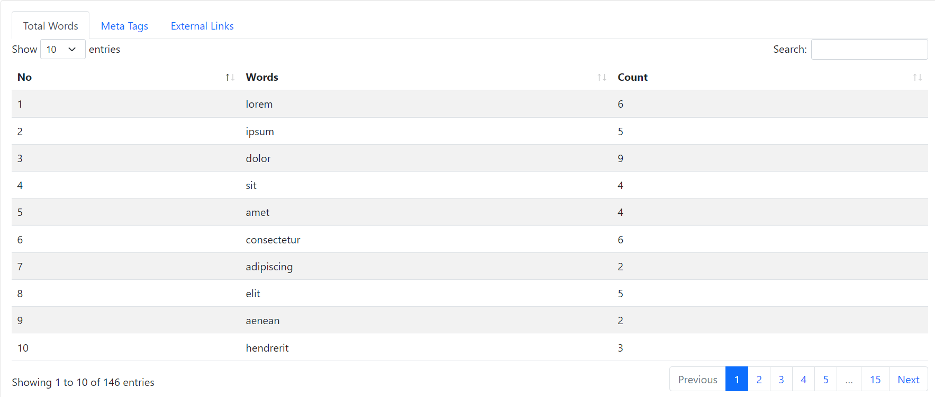

Depending on the filter, stop words may be filtered out as well, and the result tabs will follow what’s filtered as well. You can sort the result table by clicking on the table headers.

1. URL

If URL are used, read the whole content of the submitted web page and analyse based on the filter submitted.

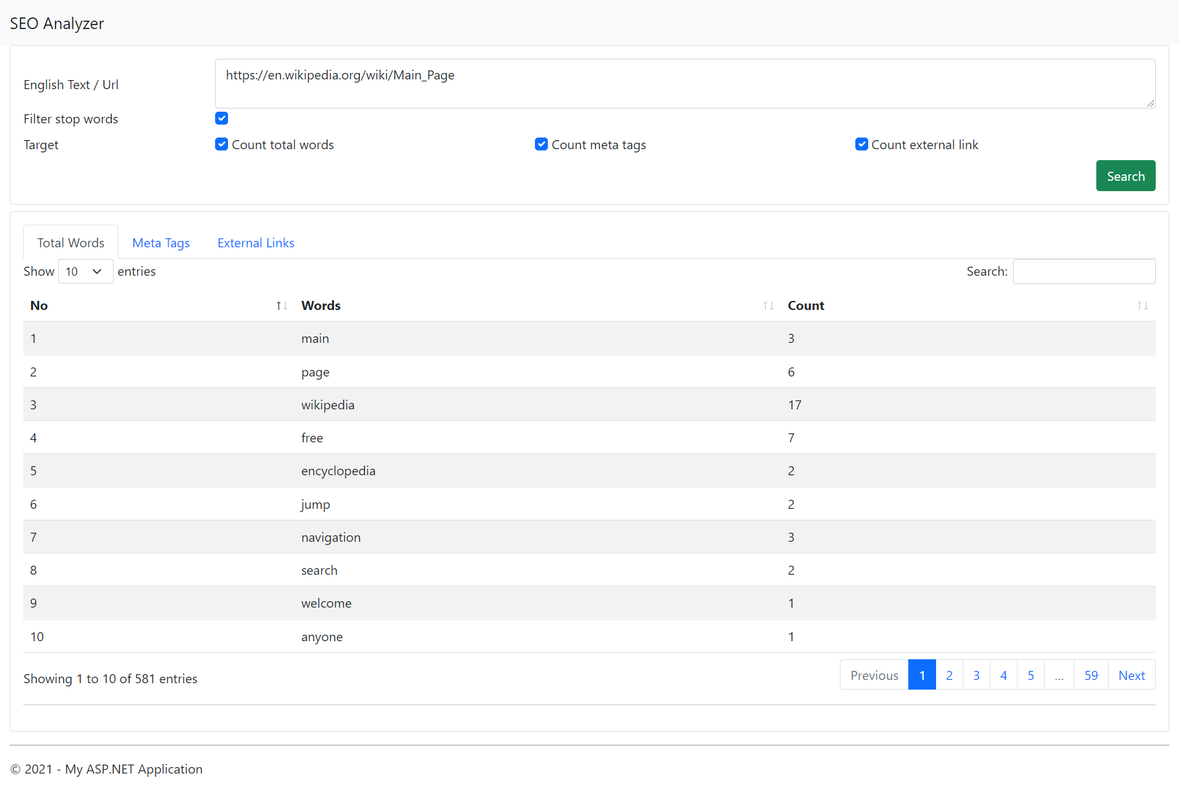

1. Exception handling

Most of the codes are covered in try catch statements which normally will log the exception details to the database, but not on this implementation as DB are not provided yet. When an error happens, it will prompt an alert to the user that an error has occurred. If there’s any unhandled exception happens, it will be caught by the global exception handler. There the exception will be logged as well and the user will be redirected to respective error.

1. Known concern

Below is the list of known concern that might happen:

* 1. SEO stop words may be not complete
  2. Word separator may not be enough
  3. Logic to determine whether an URL is a valid or not could be improved.

